**TREASURED KIDS NEST NURSERY AND PRIMARY SCHOOL**

**BABY CLASS NUMERACY**

**Name**: ________________________________________

1. **Read the following numbers I - I0.**

I 2 3 4 5 6 7 8 I0

o

1. **Copy number I**

I I I

I I I

1. **Trace the following numbers.**

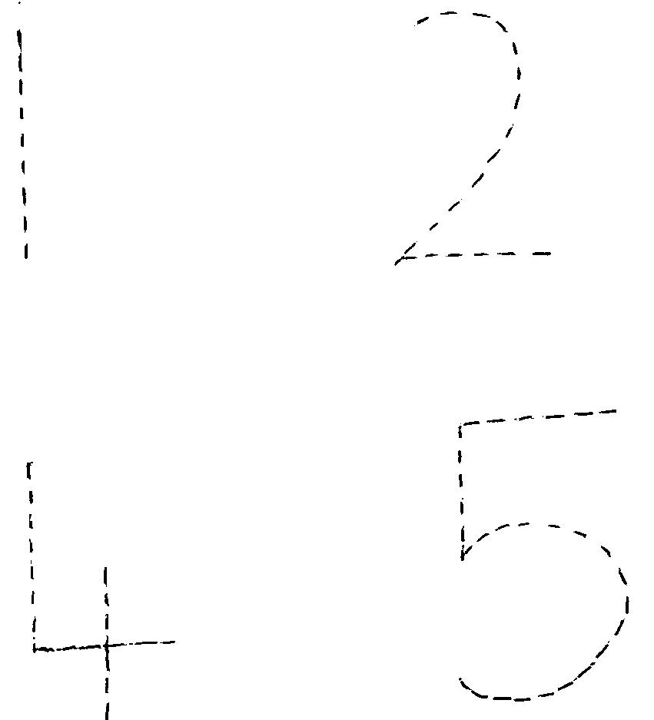 

** **

1. **Match the same number.**

I 5

2 4

3 2

4 3

5 I

1. **Colour and complete these shapes.**



1. **Count and match numbers to pictures.**

|  |  |
| --- | --- |
| I |  |
| 2 |  |
| 3 |  |

1. **Match the same shapes.**

|  |  |
| --- | --- |
|  |  |
|  |  |
|  |  |
|  |  |

1. **Match the same numbers and shade the objects.**

|  |  |  |
| --- | --- | --- |
| 2 | 5 |  |
| 4 | 2 |  |
| 5 | 4 |  |

1. **Shade numbers 4 and 5.**

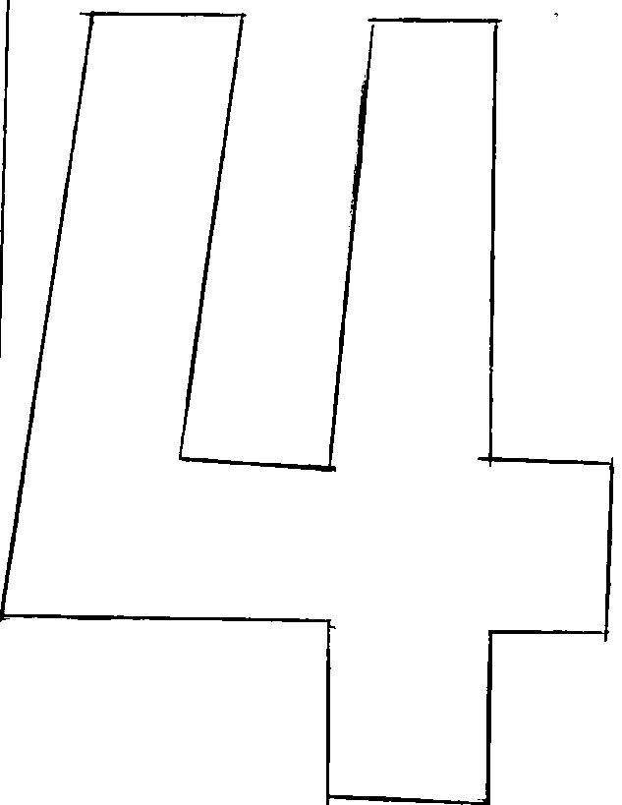

**5**

**success**